COVID-19 Testing & Inequities
STEM Global Teacher Workshop
Fred Hutch Science Education Partnership| fredhutch.org
https://www.wghalliance.org/initiative/stem-global/resources/
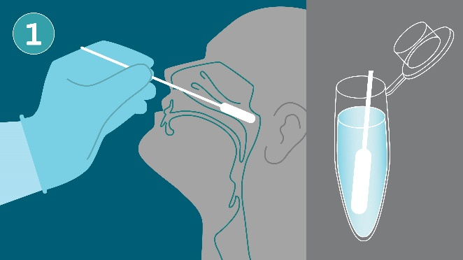
Time: 10-12 50-minute class periods for the full unit. During the STEM Global Educator Workshop, the focus of the presentation will be on Lesson 5: COVID Health Inequities.
Subject & Grade Level(s): HS Biology, HS AP Biology, HS Biotechnology
Brief Overview: In this seven-lesson unit, students develop an understanding of molecular biology through an exploration of viral and antibody testing used for detecting SARS-CoV-2 infections, which causes the disease known as COVID-19. Students also learn about and discuss health inequities and bioethical issues related to the COVID-19 pandemic. All lesson plans include suggested adaptations for virtual learning settings, including alternate activities for the two wet labs.
The unit is launched with the lesson, Diagnostic Testing Intro. Students will learn how scientists test for viral infections, including the use of molecular testing and antibody testing. In the Molecular Testing lesson, students will conduct a wet lab using gel electrophoresis to examine a patient sample to determine if they are positive, negative, or inconclusive for COVID-19 infection. In the Antibody Testing lesson, students will conduct a second wet lab, running an indirect ELISA to see if their patient has had an infection with SARS-CoV-2 in the past. With the information from their patient case study and the results of both viral and antibody testing, students will make a diagnosis and further recommendations for their patient.
Over two lessons, COVID-19 Bioethics and COVID-19 Health Inequities, students will engage in thinking and discussing the bioethical principles involved in developing a vaccine distribution strategy. They will examine data related to COVID-19 health inequities, read about how structural racism drives those disparities, and will engage in a seminar discussion about how communities of color are impacted by and experiencing the pandemic.
Next, in COVID-19 Tracking and Genomic Data, students explore COVID-19 genomic data using the Nextstrain data visualization tool in order to analyze the viral evolution and spread of SARS-CoV-2. A final lesson plan is currently under development: Policies and the Nature of Science. In this lesson, students will construct a timeline that maps how scientific understandings of SARS-CoV-2 and COVID-19 have unfolded, and how the public chooses to respond to this scientific knowledge.
This unit engages students in learning about molecular biology through an authentic, contemporary, and highly relevant topic. It also incorporates opportunities for engaging with productive uncertainty, developing scientific argumentation practices, and considering bioethical implications of scientific discoveries and policy decisions.

STUDENT UNDERSTANDINGS
Anchoring Phenomenon/Design Problem: The COVID-19 global pandemic began in Wuhan, China in 2019 and began unfolding across the world in early 2020. This created an urgent need for the rapid development of scientific discoveries related to understanding the novel coronavirus SARS-CoV-2, identifying COVID-19 infections in people, developing treatments for the disease, and informing policy decisions to protect public safety. One area of urgent need was the development of viral and antibody testing strategies. Tests were needed that could quickly, accurately, and cost-effectively identify both current and past COVID-19 infections; moreover these tests needed to become rapidly available to health care workers in every country of the world and be quickly processed in laboratories so that results could be quickly shared with patients and their health care providers. Questions about accuracy, access, and cost for these tests all have important implications for public health and health outcomes.
Driving Questions:
- How do you know if you have COVID-19?
- How do you know if you already had a COVID-19 infection in the past?
- Who gets tested and why?
- How do bioethics and health inequities relate to COVID-19 testing?

NEXT GENERATION SCIENCE STANDARDS
This lesson builds toward the following bundle of high school level life sciences Performance Expectations (PEs) from the Next Generation Science Standards.
From Molecules to Organisms: Structures and Processes
- HS-LS1-1 Construct an explanation based on evidence for how the structure of DNA determines the structure of proteins which carry out the essential functions of life through systems of specialized cells.

Heredity: Inheritance and Variation of Traits
- HS-LS3-1 Ask questions to clarify relationships about the role of DNA and chromosomes in coding the instructions for characteristic traits passed from parents to offspring.

Biological Evolution: Unity and Diversity
- HS-LS4-2 Construct an explanation based on evidence that the process of evolution primarily results from four factors: (1) the potential for a species to increase in number, (2) the heritable genetic variation of individuals in a species due to mutation and sexual reproduction, (3) competition for limited resources, and (4) the proliferation of those organisms that are better able to survive and reproduce in the environment.
- HS-LS4-3 Apply concepts of statistics and probability to support explanations that organisms with an advantageous heritable trait tend to increase in proportion to organisms lacking this trait.
- HS-LS4-4 Construct an explanation based on evidence for how natural selection leads to adaptation of populations.

Science is a Human Endeavor and Nature of Science (Appendix H)
- Science is a Human Endeavor
- Science Addresses Questions About the Natural and Material World

Download this lesson plan and associated student handouts at the STEM Global Resources page: https://www.wghalliance.org/initiative/stem-global/resources/

Credit: This activity was originally developed by Fred Hutchinson Cancer Research Center for use with their Science Education Partnership program and adapted for a STEM Global Teacher Workshop in January 2021. Fred Hutchinson Cancer Research Center is a research institution located in Seattle, WA that brings together a multidisciplinary group of scientists and humanitarians working together to prevent, diagnose, and treat cancer, HIV/AIDS, and other diseases. The Science Education Partnership supports secondary science teachers in professional development opportunities including workshops, curricula, and science mentorships. This curriculum was authored by: Regina Wu, Frontiers in Cancer Research Program Manager; Hanko Osuga, Science Resource Coordinator; and Jeanne Ting Chowning, PhD., Sr. Director of Science Education.

